Quiz#5
Section: __________________________ Group: _______________________
Name(print): ______________________________ Student ID: _________________________
- Given an airplane’s velocity relative to the wind as ${\vec{V}}_{aw}$, the wind’s velocity relative to the ground as ${\vec{V}}_{wg}$, and the airplane’s velocity relative to the ground as ${\vec{V}}_{ag}$, identify the correct vector tip-to-tail triangle representing the relationships between ${\vec{V}}_{aw}$, ${\vec{V}}_{wg}$ and ${\vec{V}}_{ag}$.
A | 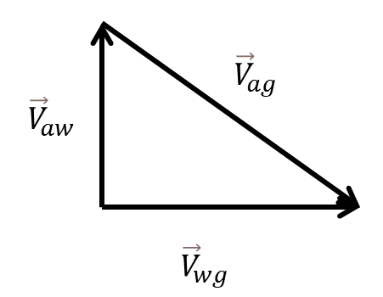 | B | 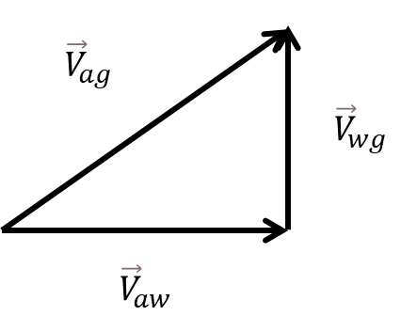
C | 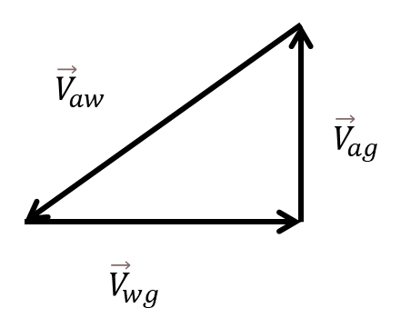 | D | 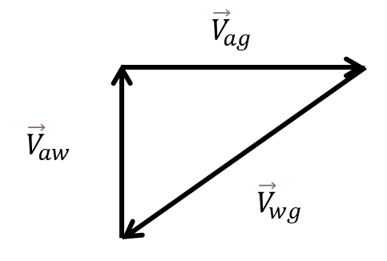

- Two stacked boxes as shown below. According to Newton’s third law, which of the following statements is a pair of Newton’s third law forces?
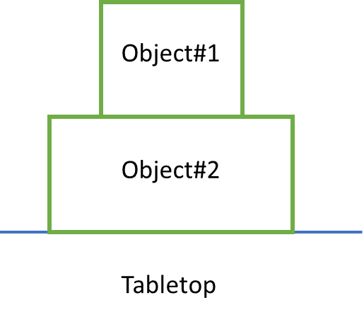
- The normal force object#2 exerting on object#1 and the gravity of object#1
- The gravity of object#1 and the downward push object#1 exerting on object#2.
- The normal force object#2 exerting on object#1 and the gravity of object#2.
- The normal force object#2 exerting on object#1 and the downward push object#1 exerting on object#2.

Using the five-step problem-solving strategy, solve the following problem:
- A block with a mass of 2.1 kg is pushed across a horizontal tabletop by a force of 15 N as shown below. The coefficient of kinetic friction between the block and the tabletop is 0.28. Determine the magnitude of the acceleration of the block.


